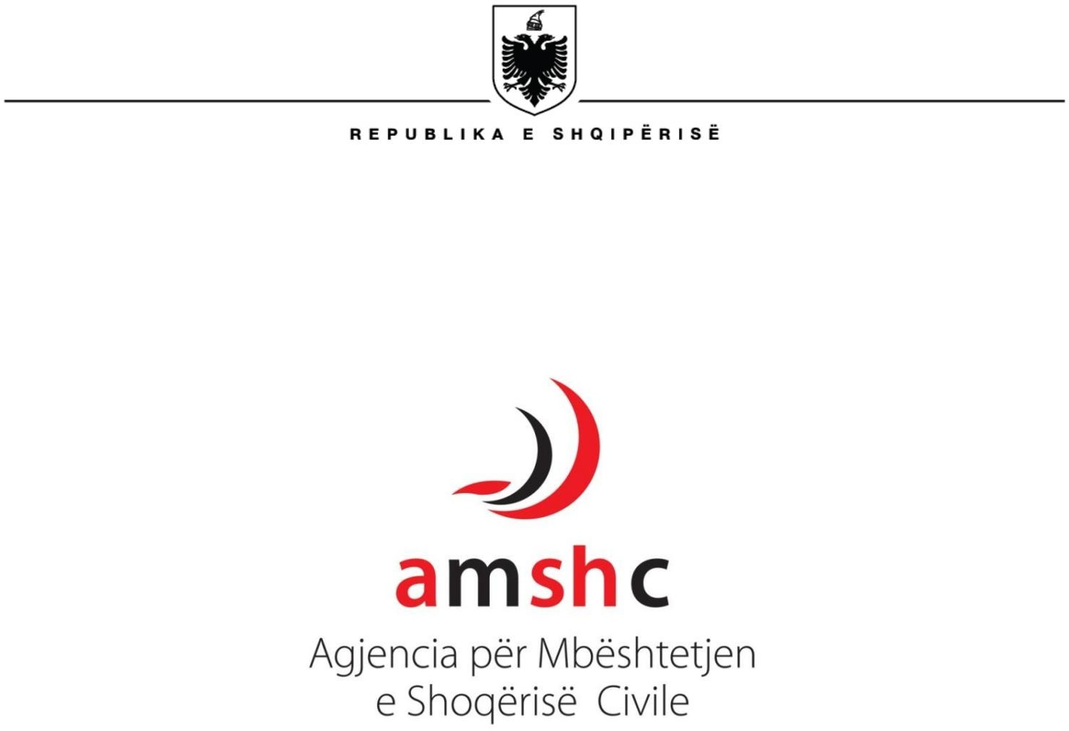

**AGENCY TO SUPPORT THE CIVIL SOCIETY**

LONG-TERM STRATEGY

2022-2026



**Executive summary**

**Civil Society Support Agency (ASCS) based on the National Strategy for Development and European Integration (NSDEI) 2024–2026, the National Plan for European Integration 2024–2026** and based on Decision No. 539, dated 25.7.2019 "On the approval of the Roadmap for the Government's policy towards an enabling environment for the Development of Civil Society 2019 -2023", revised and the Action Plan for the implementation of the Roadmap,

updates and reviews the preparation and implementation of a new strategic plan to guide/enhance its efforts to transform and highlight itself:

* As an essential engine in Albania's national development on the path towards European Integration EU.
* As a donor of European standards, equal to other similar agencies in Europe and the region.
* As a donor/grantee that focuses on “Transparency” and “Quality” in financing and monitoring of project proposals.
* As a donor able not only to finance projects, but to provide high-quality technical assistance to civil society, analysis, public consultations, being an Institution with an impact that ensures a full impact on decision-making and policy-making.

The Civil Society Support Agency Strategy for 2022 – 2026 recognizes and appreciates the extraordinary efforts and investments needed to build and make more

operational work of the AMSC since its establishment as an Institution. The procedures and rules for grant-taking have already been installed and developed, focusing increasingly on the digitalization of procedures to increase work efficiency and transparency to the public.

However, from 2009 onwards, it is necessary to take new actions to establish a new level of functioning of the AMSCS at a new level of improvement from both a technical and administrative point of view.

The new strategy sets out strategic goals that the Supervisory Board will take responsibility for achieving. These are:

* **Goal 1: AMSC continues to establish itself as a transparent and fair organization/institution in the grant-making process, with a performing Supervisory Board**

**high in service of the best interests of Albanian civil society**

* **Goal 2: AMCS strengthens inter-institutional cooperation between government and civil society by serving as a bridge for an enabling environment for civil society**
* **Goal 3: AMCS strengthens the human and technical capacities of its administration and improves the digital infrastructure for funding procedures** • **Goal 4:**

**AMCS procedures and reports on the impact of projects**

**(grant-taking) are in the interest of Albanian society and vulnerable communities.**

* **Goal 5: ASCS is a reliable channel for foreign donors regarding grant distribution.**

**Meanwhile, in addition to the above-mentioned goals, ASCS aims to achieve such objectives: long term as follows:**

1. ***“Civil society capacity development”:*** Supporting and empowering civil society organizations through training, grants, and programs that increase their capacities to positively impact the social and economic development of the country.
2. ***“Promoting civic participation”:*** Encouraging civic engagement and dialogue between public institutions and civil society to strengthen democracy and transparency in decision-making.
3. ***“Providing financial support”:*** Providing funding and grants for projects that contribute to social, economic, and cultural development, as well as the empowerment of marginalized groups.
4. ***“Enhancing cross-sectoral cooperation”:*** Developing partnerships between the public, private and civil society sectors to help solve complex social issues and promote sustainable development.
5. ***“Monitoring and impact evaluation”:*** Establishing clear mechanisms for monitoring and evaluating supported projects, to ensure the transparency and effectiveness of funding provided by the agency.
6. ***“Promoting democratic values and human rights”:*** Promoting respect for human rights and democratic values through supporting initiatives aimed at improving governance and social inclusion.
7. ***“Building capacities for self-sustainability”:*** Providing support to civil society organizations to build their financial sustainability models and diversify funding sources.

Together, these goals are designed to consolidate the procedures and measures taken for the functioning of the Agency and to lay the foundations for the future of the Agency. At the same time, they are ambitious and many of them may need to be continued in the next strategic period. The Agency, being the central mechanism for public financing of CSO programs in Albania, has challenges and work ahead of it to improve its functioning, and in particular to redefine its role and work to be more proactive and closer to CSOs at the local level, transparent programming of funding priorities, collection of increasingly reliable data on CSOs and support for the balanced development of civil society throughout

the country. Special attention should be paid to the preparation of clear criteria and procedures for the allocation of institutional grants to CSOs, as they are the main drivers for the sustainability of mission driven CSOs.

1

1 Roadmap for Designing Policy and Measures for an Enabling Environment for Civil Society

In order to ensure the most effective monitoring of the work of the AMCS and the harmonization of funding priorities with both national strategic plans and the needs of CSOs, the AMCS should continue to actively participate in the work of the National Council for Civil Society (NCCS) in implementation of Law No. 115/2015 *“On the Establishment and Functioning of the National Council for Civil Society”.*

*Civil Society”,* playing the role of the Council Secretariat efficiently and responsibly, and serving as a bridge for strengthening cooperation and inter-institutional dialogue between the Albanian government and the civil society

sector.

2 The KCSC is an autonomous collegial advisory

body under the Council of Ministers of the Republic of Albania, regulated by Law No. 115/2015.

At the same time, achieving these strategic objectives requires further strengthening of the capacities of the Agency's staff, in order to gain the trust of civil society and the general public in its integrity and honesty.

The Supervisory Board will oversee the implementation of the strategic plan, the Executive Director is responsible for its implementation.

**The Unique Nature and Characteristics of ASCS**

AMSC is a unique agency in Europe in that it is an independent Albanian government agency, funded with a legally mandated mandate to serve and strengthen the civil society sector in the country. Being funded from the central state budget, it has a stable level of funding and is accountable to Albanian taxpayers.

This unique nature of the Agency allows it to develop strategies and priorities in the best interest of the country’s development. The priority to support all new NGOs is another important distinguishing factor of AMSC which allows it to engage with Albanian civil society in a more inclusive manner.

As an agency operating in an environment where many CSOs are skeptical, all ASCS staff are willing to take measures to improve the perception of the Agency's transparency and fairness.

In addition, the national character of the Agency allows it to interact on a wider geographical scale.

spread throughout the country and to build relationships with organizations and communities.

spread in rural and isolated areas. Responding to Albanian society, as a key component, AMCS should be regularly engaged with Albanian civil society. In this way, AMCS should be active and a continuous participant in the civil society sector of the country.

2 Roadmap for Designing Policy and Measures for an Enabling Environment for Civil Society

**Analysis of the context of civil society and the functioning of the ASCS**

In a general analysis, the civil society sector in the country is characterized by a great challenge but at the same time optimistic. The main strategic document that regulates an enabling environment for the civil society sector is the Civil Society Roadmap 2019-2023.

The creation of an enabling environment for civil society organizations is one of the prerequisites and measures for a sustainable democracy in a modern state. This environment should guarantee favorable fiscal and legal conditions for civil society and create space for media freedom, independent institutions, freedom of speech,

as well as for the fundamental rights of man and citizen. One of the basic features of democratic governments is the obligation of the state to be at the service of its citizens. Dialogue and cooperation between state authorities and civil society are in the direct interest and good of the public and, consequently, a prerequisite for the well-functioning of an inclusive society. Good cooperation between a service-minded government and an active, critical and constructive civil society constitutes an indispensable element of pluralistic democracy,

**Social context** 1

There are a large number of civil society organizations in the country. The Tirana Court of First Instance reported 7,580 registered CSOs by the end of 2017, which is also the latest available data on the official size of the CSO sector.

* 1. The Albanian government is much more open to cooperating in a way

very constructive and efficient with civil society organizations. The organization and functioning of the AMCS in itself can be considered an indicator of governance and an expression of openness for cooperation. At the same time, an expression and strengthening of the dialogue with citizens and civil society organizations (CSOs) in the process of drafting public policies is the approval of Decision No. 539, dated

25.7.2019 *"On the approval of the Roadmap for Government Policy*

*"Towards an Enabling Environment for Civil Society Development 2019 -2023"*

* 1. Albanian citizens – especially vulnerable groups – are increasingly aware of their rights and publicly engage in their protection.
  2. Civil society organizations in the country have expanded connections and increased networking with partner organizations in Europe, with the aim of increasing and strengthening their capacities.
  3. Civil society organizations are generally willing to develop and embrace innovative

trends.

Yet civil society faces a number of challenges. The main challenges facing civil society today are:

* Both civil society and the population/community itself have a kind of skepticism despite the will of the Albanian Government and its commitment to creating a healthy environment that encourages the independence, efficiency and sustainability of civil society, contributing to bridging the gap between citizens and institutions.
* Civil society organizations concentrated in central Albania, especially in Tirana, continue to dominate the sector. Other organizations are spread mainly in the North (Shkodër) and the South (Korçë, Fier and Vlorë).
* The registration process continues to be centralized at the Tirana Court of First Instance, creating a concern for CSOs outside the capital. CSOs need to travel to the capital not only to register, but also to make changes to their statutes, including addresses.
* Local organizations are less present and lack technical and organizational capacities, therefore they are unable to absorb funds from donors.

otherwise (although the AMSHC in its calls for project proposals has aimed for the widest possible geographical distribution as well as new organizations.

* Civil society still suffers in finding the circulation of volunteers despite the Law on Voluntary Work which aims to regulate voluntary work with the aim of increasing the participation of individuals in social life, improving the quality of life.
* The legal environment regarding the reimbursement of value added tax (VAT) for purchases made with donor grants CSOs benefit from tax exemptions and reimbursement of value added tax (VAT) for purchases made with donor grants is still problematic for civil society.

**Analysis of the current situation and achievements of the AMSHC**

Since its establishment in 2009, AMSC has made efforts since its start-up

large investments, management capacity, human resources, funding procedures; regulations, monitoring procedures, reporting, etc. During the first years, AMSC used the funds in accordance with the law and government procurement rules. Most of these efforts have been bureaucratic and operational. As a new agency with a relatively small staff, this process has been commendable.

At this moment, there is a need to improve the procedures for distributing public funds.

which are described only in the law on the Agency for Civil Society Support (ASCS) and other internal regulations of the ASCS.

***Current Strength and Achievements***

***Beginning.*** Since its establishment; AMSC has established a series of key functional priorities such as monitoring, reporting, financial oversight and administration (see Annex B Current Staff Structure).

The agency has announced calls for project proposals each budget year and disbursed more than 400 grants to Albanian CSOs with an average of 70 projects per year. Both the disbursement of grants and their monitoring have been applied in accordance with the law and government financial procedures.

***Outreach to Albanian Civil Society.*** ASCS staff have traveled to cities in all regions of Albania specifically to reach and engage with all local civil society groups. These information and consultation meetings have been held to gather data,



issues that concern and interest these groups and to train them about the Agency's objectives and procedures for grant funding.

***Efforts to increase trust and transparency. The staff of*** the ASCS is fully focused on the need to build trust and transparency between civil society and Albanian taxpayers. This has been addressed primarily through the extension and strict adherence to rules and regulations related

to the establishment and monitoring of grants. The AMSHC has made public its funding and

grants and all related procedures now also in implementation of the Law on the Right to Information and Protection of Personal Data, through a Quality Program

and interactive Transparency on the official online website of the Institution.

As evidence of these achievements, ASCS has calculated that the quantity of applications has been steadily increasing in each new call for proposals, but also the quality of the projects, both in The implementation of activities but also in reporting, was increasingly improving, demonstrating an increase in the technical capacities and human resources of NGOs and Civil Society in country. While many CSOs naturally need grant funding, this is also a sign that more and more CSOs are grateful to AMCS and want to partner with it.

# Strategic objectives of the AMSHC for the period 2022-2026

As described above, AMSC has achieved a lot in putting the elements into operation. mechanics of operations, procedures and techniques for efficient grantmaking and monitoring.

*NOTE: It should be noted that this is a strategic plan. The Supervisory Board will lead in achieving the strategic goals and objectives listed in this plan. The Director and his staff will implement*

*the plan throughout the strategy period.*

# Agency Vision

ASCS is an important engine in Albania's development and EU integration, in partnering, motivating, and equipping civil society to achieve sustainable impact.

# Agency Mission

To encourage the sustainable development of civil society and the creation of favorable conditions for civic initiatives for the benefit and in the interest of the public.

# Key values of ASCS:

* Continued support for Albania's development and integration

EUROPEAN

* Commitment to Albanian civil society
* Compliance with Albanian laws
* Transparency
* Justice
* Professionalism



**ASCS 's Vision**

ASCS is an important engine in Albania's development and EU integration, in partnership and the continued support of civil society to achieve sustainable impact.

**Agency Mission**

The Agency's mission is the sustainable development of civil society and the creation of favorable conditions for civic initiatives for the good and interest of society.

Civil Society Support Agency (CSSA): ***Long-Term Strategy 2020-2025*** 8



**Goal 1:** **ASCS continues to establish itself as a**

**transparent and fair organization/ institution in the grant-making process, with a Board**

**High-performance supervisor in**

**serving the best interests of Albanian civil society**

***Objectives:***

*1: The Supervisory Board's capabilities, collaborations and management mechanisms are optimized for its strategic decision-making and governance of the AMSC.*

*1.2 Mechanisms for setting priorities and selecting grants have been strengthened and*

*adapted to the principle of inclusiveness*

**Goal 2: ASCS**

**strengthens inter- institutional cooperation**

**between government and society civil service serving as a**

**bridge for a**

**enabling environment for civil society**

***Objectives:***

* 1. *: AMSC is widely recognized as the secretariat of the National Civil Society*

*Council*

* 1. *:* ***ASCS*** *increases the transparency of the work of the KCSC through continuous information*

*about the Council's activities and maintenance of the official online website of the KCSC.*

* 1. *: AMCS in the capacity of*

*the technical secretariat of the KCSC*

*strengthens the consultation process between civil society*

*and public institutions as well as follows the requests of NGOs regarding the implementation of the*

*Roadmap for an Enabling Society Environment*

*Civil.*

**Goal 3: ASCS strengthens the human**

**and technical capacities of its administration and improves**

**the digital infrastructure for financing procedures**

***Objectives:***

* 1. *: AMSC is an effective advocate and promoter for civil society concerns.*
  2. *:* **ASCS** *is an innovative force for civil society, through technical assistance and funding*
  3. *:* **ASCS** *staff has the technical capacity to manage*

*programs and transfer knowledge to civil society*

* 1. *: The grant application process is transparent and more efficient through a process of digitalization*

**Goal 4: ASCS procedures and reports on the**

**impact of**

**projects (grant-making) are in the interest of society**

**Albanians and vulnerable**

**communities.**

***Objectives:***

* 1. *: AMSC has improved capacity and mechanisms to establish priority areas of*

*need-based grantmaking communities and to effectively monitor its grants*

* 1. *:* **ASCS** *demonstrates value, impact and contributions to*

*developing national, European and global goals through grant-making*

**Goal 5: ASCS is a reliable channel for foreign donors regarding grant distribution.**

***Objectives:***

* 1. *:* **ASCS** *is recognized*

*as a reputable organization, a reliable grant-giver by foreign donors*

* 1. *:* **ASCS** *allocates and manages at least 20% of the annual budget with funding from external donors*

Civil Society Support Agency (CSSA): ***Long-Term Strategy 2020-2025*** 9